**LAB#5**

# Asynchronous JavaScript & Web APIs

**OBJECTIVE:** To master asynchronous JavaScript concepts (Promises, async/await, Promise combinators) and web manipulation techniques (DOM, BOM, Events) through practical implementation.

**Student Task**

**Task 1: Understanding Callbacks and setTimeout.**

**CODE**

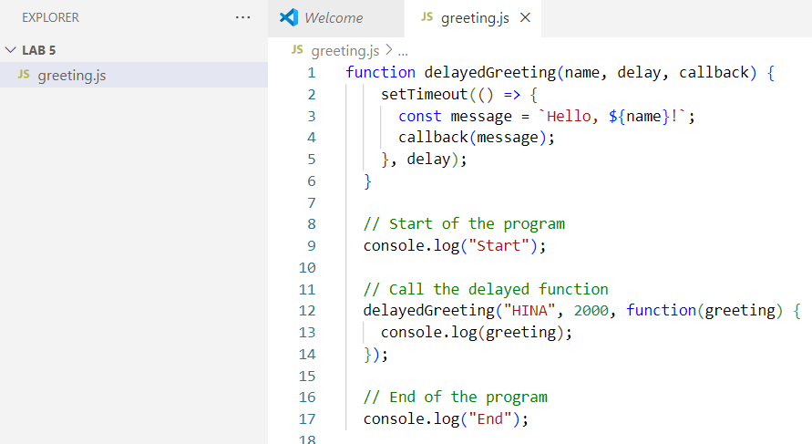

**OUTPUT**

**Task 2: Converting Callbacks to Promises.**

**CODE**

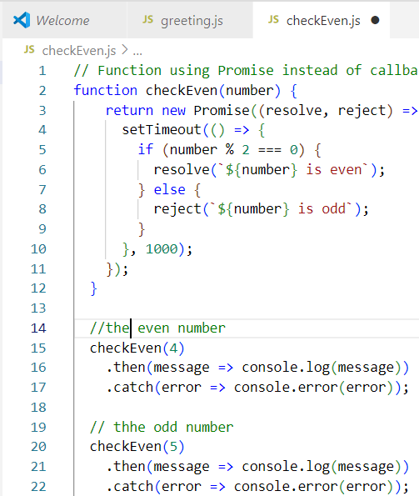

**OUTPUT**

* **Task 3: Using async/await with Fetch.**

**CODE**

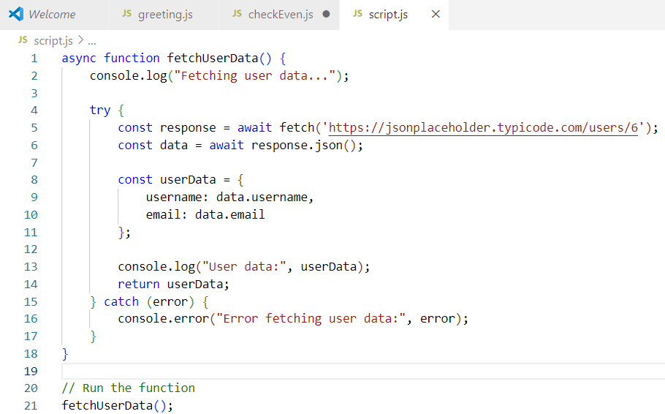

**OUTPUT**

* **Task 4: Promise Combinators.**

**CODE**

* **runAll Tasks**

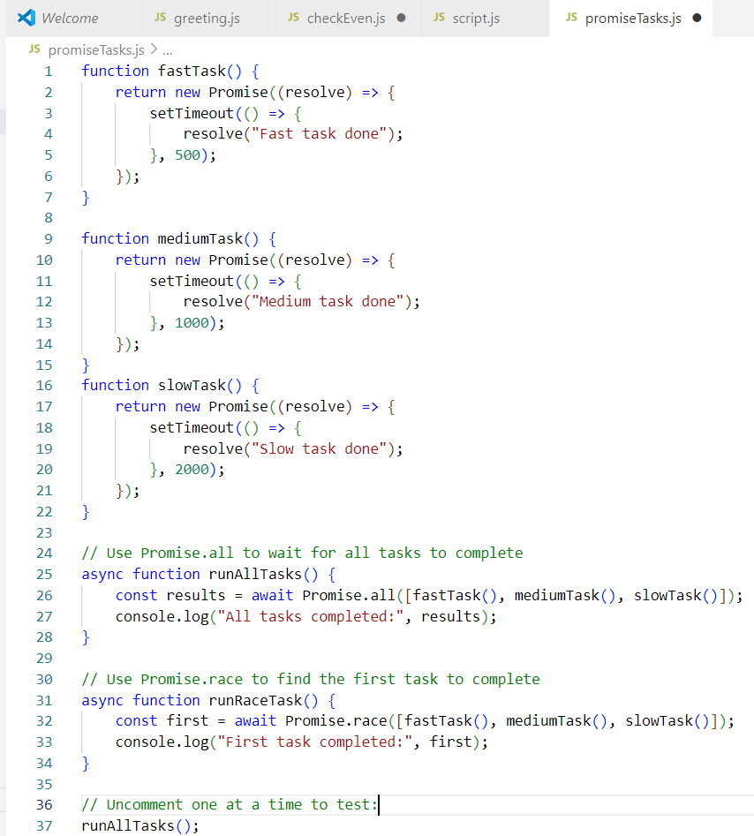

**OUTPUT**



* **runRaceTask();**

**OUTPUT**

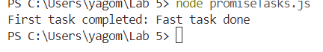

* **Task 5: DOM Manipulation.**

**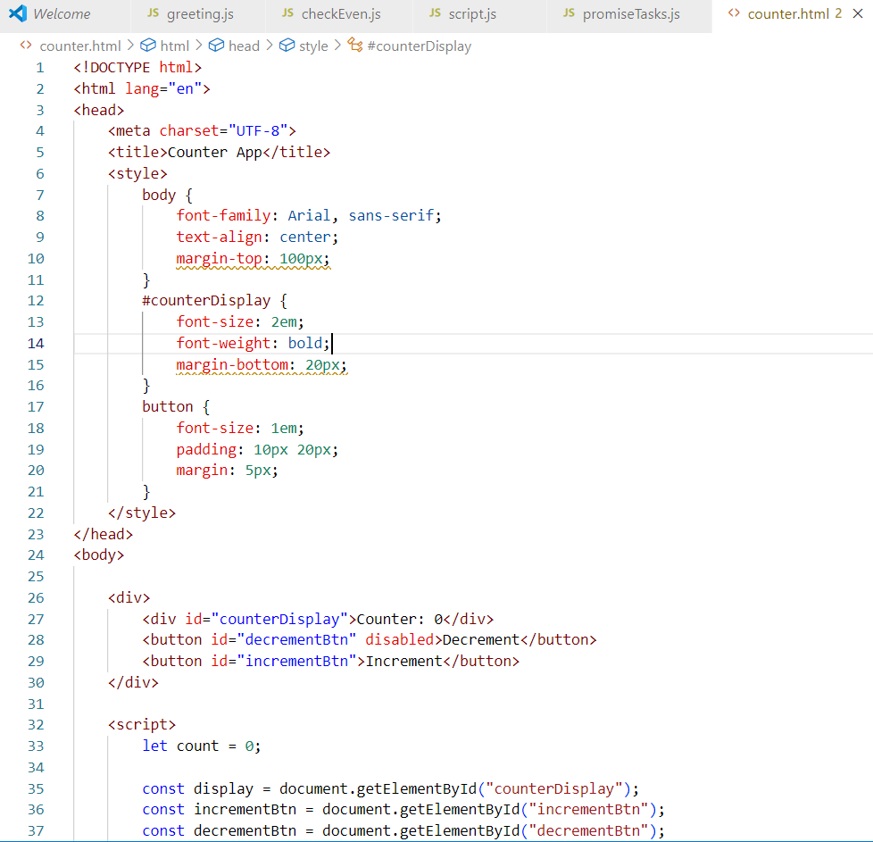CODE**

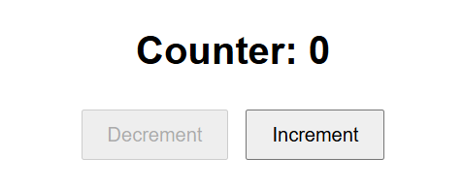**OUTPUT**

* 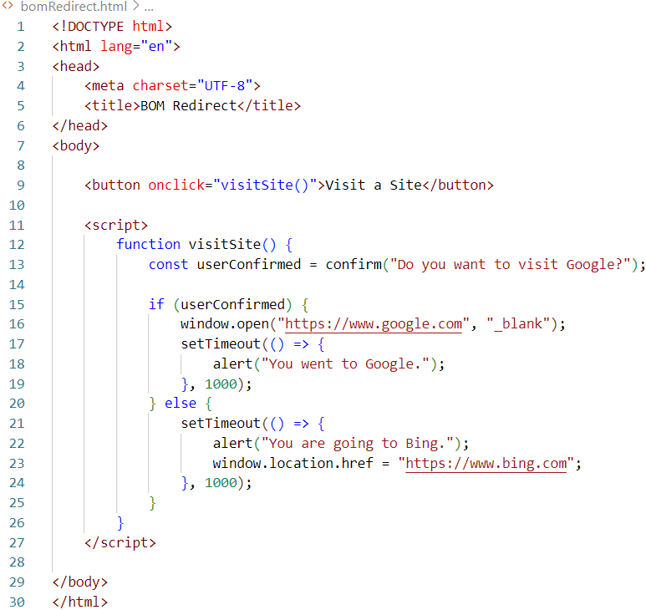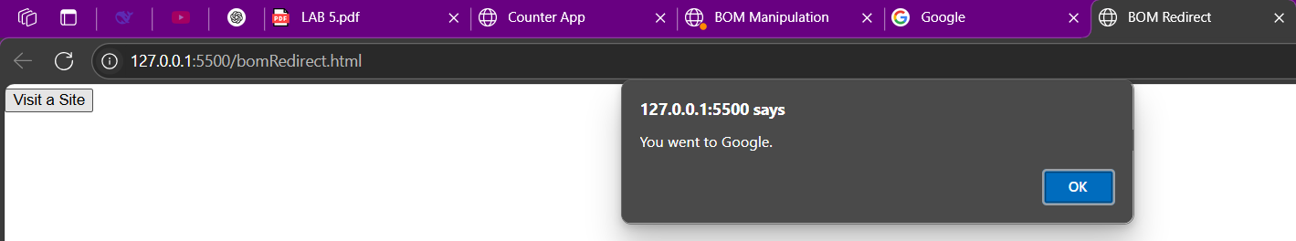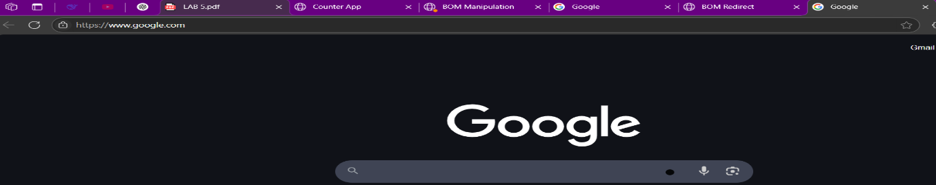**Task 6: BOM Manipulation.**

**CODE**

**OUTPUT**